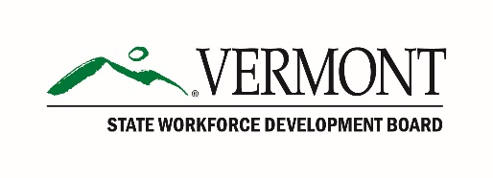
Vermont State Workforce Development Board
Operating Committee
Conference Call Agenda
March 26, 2019, 10:00 – 11:00 am

10:00 am Call to Order

10:05 am New Chair Introduction
Adam Grinold, Chair, SWDB

10:15 am Next Full Board Meeting

10:30 am Legislative Update: H.533 An act relating to workforce development
Commissioner Lindsay Kurrle, Department of Labor

10:55 am New Business

11:00 am Adjourn

