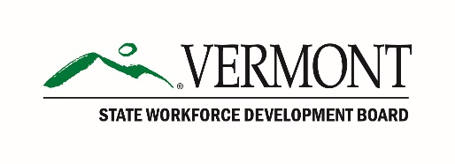

Vermont State Workforce Development Board

Career Pathways Committee Meeting Agenda

March 7, 2019, 9:00 – 10:00 am

Vermont College of Fine Arts, Montpelier, VT

9:00 am Call to Order

9:05 am Review Proposed Criteria for Committee Review of Career Pathways

9:35 am Discussion: Timeline for Development of Approval Process

10:00 am Adjournment