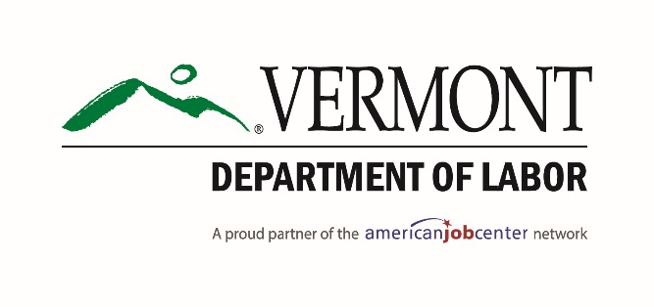
Dear Employers and Community Partners:
Vermont Department of Labor and Addison County Workforce Development Task Force would like to take this opportunity to invite you to the Career & Job Expo, scheduled on Thursday, November 15, 2018, from 10:0am - 2:00pm. Veterans’ preference will be from 10:00am – 11:00am. The location for this event will be at the American Legion Post 27, 49 Wilson Road, Middlebury, VT.
Get maximum results and conserve resources by condensing your recruiting efforts in this one day event.
- Meet face to face with job candidates.
- Profile employment opportunities your organization has to offer.
- Build your resume database for current and planned recruiting initiatives.
- Network with local and regional employers, gain exposure and visibility for new and expanding businesses.
- Provide an opportunity for businesses to meet with area’s high school students to showcase your business and talk about the different careers within your company.
- Help area students to obtain information on career opportunities within Addison County and Vermont.
Your participation is needed to make this Career & Job Expo successful. We can keep our most valuable resource here in Addison County and Vermont, our youth and future workforce. Don’t delay! Please respond with the attached registration form and return it via email to michelle.thompson@vermont.gov; or kim.collins@vermont.gov; or fax to 802-388-4630 to reserve your space. Space is limited, registration will end on November 1, 2018, or before. There is no fee for this Career & Job Expo. Lunch will be provided.

